Electric Vehicle Charging Infrastructure – the role for local government

Purpose of report
For discussion and direction

Summary
There are a range of roles that councils already play in supporting the roll out of electric vehicles and the Government have made resources available to help with local investment and know-how. However, the Government have set ambitious targets for the transition to a zero-emission fleet and looking ahead councils are unclear what they need to prioritise and what the Government sees as local government’s key functions. In order to help with its work to influence future Government policy and support for councils the LGA is working with Local Partnerships to provide clarity and also help address issues of capacity, capability and expert support that councils will need, in particular for on-street charging provision. This will help influence future Government strategy as well as future Government spending decisions. This is an early opportunity for the Board to feed into this work. Jo Wall from Local Partnerships will help facilitate a discussion with the Board.

Recommendation
The item is for update and discussion.
Action
As directed by the Board

Contact officer: Kamal Panchal
Position: Senior Adviser
Phone no: 0771 7572640
Email: kamal.panchal@local.gov.uk

Electric Vehicle Charging Infrastructure – the role for local government
Background
- In July 2018, the Government set out their long-term ambition that by 2050 they want almost every car and van to be zero emission. As a steppingstone in reaching that goal, in November 2020, the Government also committed to bringing forward the date when sales of new petrol and diesel cars will end to 2030 (and hybrids by 2035).
- To underpin that move, a network of electric vehicle (EV) charging points will be required. There are a range of roles that councils already play in supporting the role out of EVs and the Government have made resources available to help with local investment and know-how. However, councils are unclear what they need to prioritise and what the Government sees as the key role for local government. Capacity and capability for councils to support the role out of EV charging infrastructure also varies, as does existing funding for on-street charging.
- On April 21st the Government laid down legislation to set the 6th carbon budget at the level recommended by the climate change commission, which is a significant increase in the cut in greenhouse gas emissions - by 78% by 2035.
- At the same time the Government published a comprehensive impact assessment, which says:
- “In the transport sector, there are major barriers of all types. Encouraging take up of electric vehicles is a major challenge, with particular difficulties around current higher vehicle costs, and charging practice and times. Most car and van technologies are mature, whilst many alternative technologies for HGVs, hydrogen trains, advanced biofuels, sustainable aviation fuels and low-carbon shipping are in development or need to be demonstrated before they can be deployed at scale. Significant cost reductions and / or government intervention will be required to enable widespread deployment of these technologies and achieve any necessary behaviour change by businesses and consumers. Production will need to scale up very significantly, especially for charging infrastructure, alternative fuel infrastructure and batteries, with the latter depending on scarce resources.”
- Modelling in the impact assessment estimates that if the Government was to follow its preferred pathway to achieving the 78% reduction this will require up to 28 million cars and vans to be electric by 2035. The graph below illustrates the scale of the challenge.
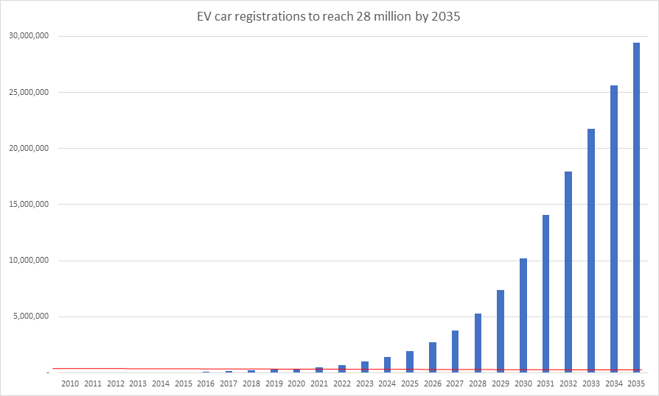
Source: DfT, Table VEH0130 - Licensed ultra low emission vehicles (ULEVs)
The red line shows current registrations at 2021. The bars from 2022 onwards illustrate what a smooth projection in growth looks like to achieve the 28 million cars and vans total as set out in the impact assessment.

- To help the LGA influence future Government investment in local authorities and local infrastructure the LGA is working with Local Partnerships to research the needs and aspirations of member councils. This work will build on existing LGA work on decarbonisation of transport and electric vehicles. Jo Wall from Local Partnerships will help facilitate a discussion with the Board.
Issues
- One third of homes have no off-street parking to enable convenient charging of EVs. EV owners without off-street parking rely on destination charging such as shops, cinemas and workplaces, or dedicated fast charging stations where available.
- On-street home charging infrastructure is intended to encourage the increase in uptake of EVs and places the lowest burden on the electricity grid.
- Councils play a number of different hard and soft roles in the roll out of on-street charging infrastructure – including: determining demand and where to locate, responding to market failure, directly providing charge points (whether on their own or in partnership with the private sector), from a special planning and planning management perspective, through managing and coordinating relevant roadworks, etc.
- The Government provides funding for councils towards delivery of on-street charging infrastructure; £20 million this year through DfT’s ‘On-Street Residential Chargepoint Scheme’ (ORCS). Councils are often unfairly criticised for not taking up this funding fully. Since 2017, ORCS has supported applications from 140 local authorities across UK, and nearly 4,000 charge points.
- Councils say there are many barriers to taking up such capital funding which many find highly restricted. These include: insufficient in-house resources and access to expertise; a confusing marketplace and commercial models; lack of clarity from central government as to the role of councils; funding schemes that appear small, short-term and not designed with the pressures on council revenues in mind.
- There are also issues relating to the quality and reliability of chargepoints; such as chargepoints being an eyesore and instances where people turn up to charge with a low battery but the unit is not working. This can undermine public confidence in EVs and from a commercial perspective the question is whether early schemes will generate enough revenue to pay for ongoing maintenance and repairs.
- OZEV are in the early stages of updating their on-street EV infrastructure strategy to encourage greater take-up of ORCS funding. Both councils and OZEV feel that they could work together much more effectively to increase the pace of roll-out.
- LGA is seeking to identify the role that councils would like to play and to identify barriers that prevent them undertaking that role and doing more to deliver the charging infrastructure suited to local circumstances and demand.
- The delivery of EV infrastructure is a discretionary function for local authorities (they are currently not responsible for providing petrol stations). In addition, the commercial market and political ambition for providing on-street charging infrastructure varies widely across the country. It is important that support and policy are of relevance and use to all councils.
- There are other issues emerging which will require local solutions and policies to deal with. For example, there is emerging evidence of people charging their EVs on roads through running charging cables across the public footpath to use their domestic electricity supply. Whilst also posing health and safety risks and liability issues for the homeowner, it has recently come to LGA officers attention that the trailing of cables in isolation appears also to be illegal and subject to a fine under Section 162 of The Highways Act 1980. Some councils have experimented with digging trenches to support the safe implementation of this practice. This potentially opens up new areas of service for councils – similar to that of dealing with requests for dropped kerbs.
- There is a social justice and equalities element in making EV car use accessible to all communities and the availability of (affordable) EV charging infrastructure will be important – especially for those areas which do not have an alternative means of mobility or private charging facilities. EV car owners may well trade off between the cost of charging using their domestic supply versus the costs of any kerb-side provision. For councils considering commercial partnering for on-street provision there are viability/ risk issues to consider and potentially issues of fair pricing and avoiding the creation of monopolies.
- Some councils have decided not to install any on-street charge points and are awaiting the outcome and evaluation of trial projects elsewhere before making any further decisions on the provision of on-street charging. For example, Suffolk County Council’s website say:
“We need to consider how we successfully balance the needs of all road users, especially pedestrians and those reliant on a safe and accessible network of footways, the type of chargers needed and who is going to fund and maintain them once installed.
As energy-storing solutions for electric vehicles is a rapidly changing technological area, there is significant potential for installed new infrastructure to soon become outdated and potentially redundant.
Apart from short-term parking locations where vehicles would be expected to come and go regularly, it is also not appropriate for specific sections of the highway to be reserved for specific individuals (for vehicle charging or otherwise).”
- Councils will therefore need access to good expert advice and sufficient in-house capacity to assess, design and deliver their EV charging objectives. The view at the moment is that in-house expertise exists only in relatively few councils and that national resources for supporting local authorities may be insufficient to meet anticipated increase in the role of councils.
- Current support for local authorities is provided through the Energy Savings Trust which includes a series of guides and also a Local Government Support Programme which “can provide tailored support to help local authorities improve local air quality and reduce carbon dioxide emissions. We can offer impartial advice on chargepoint procurement, planning policies and can facilitate a team workshop or independently review your draft plans.”
- It would be helpful for the work that Local Partnerships and LGA are doing for Board members to feedback their views based on experiences and ambitions from their own local authorities. Reflections on the following would be particularly useful:
  - The ambition, plans and roles, if any, for supporting EV charging infrastructure, especially for on-street
  - The demand and commercial market that operates locally; the risk appetite for council investment and thoughts about fairness.
  - Is there an appetite to address the strategic charging infrastructure on major trunk roads as well – ie where there is not access to an affordable connection does there need to be a role for local authorities to step in (where technically feasible)?
  - The capacity and capability of the council to support the roll out of EV infrastructure and adequacy of existing support, such as from EST and other organisations
  - Are there any areas where standardisation of processes and standards would help councils?
  - The quantum and nature of any future Government funding.
  - Are there any areas of EV charging infrastructure delivery where you think councils should not be involved with?
Implications for Wales
- The Department for Transport is developing a Transport Decarbonisation Plan, which will set out actions for government, business and society to deliver the significant emissions reduction needed across transport. The Wales Transport Strategy sets the framework for decarbonisation of the transport sector as a whole as applicable to Wales. OZEV grant schemes are available UK-wide.
Financial Implications
- No financial implications
Equalities, diversity and inclusivity
- At the moment EVs are relatively expensive compared to more conventional petrol, diesel and also hybrid vehicles (on average £10,000 more) and even with Government grants are not affordable for most people. There are also a limited number of models. This is starting to change and as more manufacturers switch production to EVs the price of EV cars is set to reduce over time.
- As for EV chargepoints they are much more convenient to install for those people with private driveways. Across the UK only 51 per cent of terraced houses have on-street parking.
- Some places have provided EVs with free or subsidised parking, or subsidised electricity during parking, and other places have allowed EVs to access bus lanes. However, there is no strong carbon case for either of these types of measures. Indeed, there are risks that privileging EVs in this way will damage attempts to shift more trips to active travel and public transport – an important step in councils’ decarbonisation plans.
- In considering the implementation of EV charging point policies some councils have noted that the siting of EV charging points could create additional barriers for people who are wheelchair users and pose an increased risk for people who have a visual impairment
- The Government has not made an exhaustive assessment of the equalities implications of achieving net zero, but it has stated that: ‘In transitioning to net zero and bringing forward policies in future, government will need to consider ways to ensure it is representative of people with protected characteristics, while minimising any potential negative impacts’.
Next steps
- The Board is invited to note the report and provide feedback to Local Partnership’s work and LGA’s future lobbying on this issue.

